Prepositions of Time

🔹 What Are Prepositions of Time?
# Source: AI Source: Provided by: [Data Path: Persons Table -> ID Column: 1, Name_En Column: Motasem Essam] -> From: [Chatgpt (GPT-4-turbo)] on [7/28/2025]
Prepositions of time are words that show the relationship between time and a noun or pronoun in a sentence.
They answer the question: When? or For how long?

✅ Common Prepositions of Time
# Source: AI Source: Provided by: [Data Path: Persons Table -> ID Column: 1, Name_En Column: Motasem Essam] -> From: [Chatgpt (GPT-4-turbo)] on [7/28/2025]
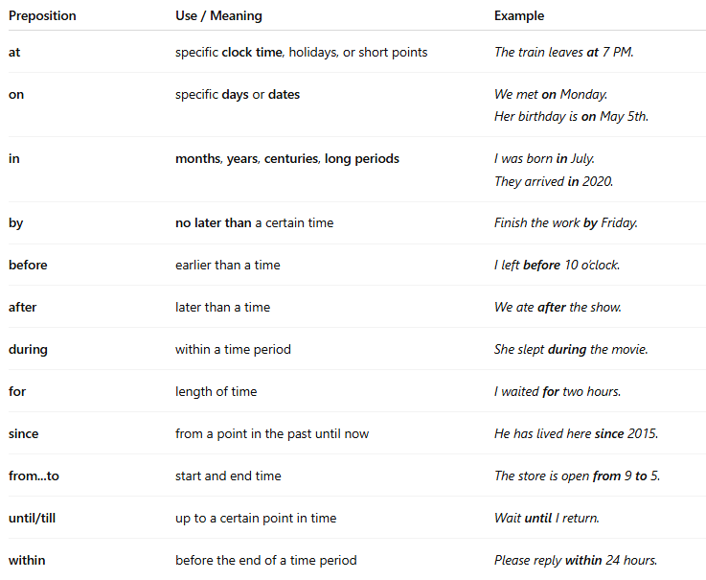

Preposition | Use / Meaning | Example
at | specific clock time, holidays, or short points | The train leaves at 7 PM.
on | specific days or dates | We met on Monday.Her birthday is on May 5th.
in | months, years, centuries, long periods | I was born in July.They arrived in 2020.
by | no later than a certain time | Finish the work by Friday.
before | earlier than a time | I left before 10 o’clock.
after | later than a time | We ate after the show.
during | within a time period | She slept during the movie.
for | length of time | I waited for two hours.
since | from a point in the past until now | He has lived here since 2015.
from...to | start and end time | The store is open from 9 to 5.
until/till | up to a certain point in time | Wait until I return.
within | before the end of a time period | Please reply within 24 hours.

📚 Example Sentences
# Source: AI Source: Provided by: [Data Path: Persons Table -> ID Column: 1, Name_En Column: Motasem Essam] -> From: [Chatgpt (GPT-4-turbo)] on [7/28/2025]
- I have class at 8:00 AM.
- We’ll meet on Tuesday.
- She moved here in 2021.
- You must submit the form by tomorrow.
- He hasn’t called since Monday.

